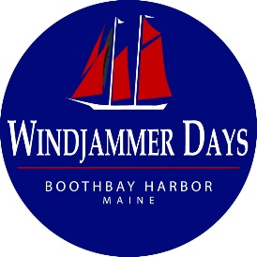

Boothbay Harbor Windjammer Days
Vintage Boat Parade
Friday, June 28, 2024
Time: 4:00 P.M.

WHO: Boats 25 years old or older: That is, new in 1998 or before.
WHERE: Boats will rendezvous off RED buoy 8 off Tumbler Island starting at 1500 hours (3 PM)
The Parade Chair will be out there in a boat monitoring VHF Channel 72.

- ORDER: The Boothbay Harbor - Harbor Master’s boat will lead the procession with the oldest boat falling in behind her, and the others forming a line based on age: older boats first to newest at the end. Larger and less maneuverable boats may be placed toward the front as needed and determined by the Parade committee. Please check in with the Parade Chair on VHF Channel 72 for instructions. Boats begin to gather at 1500 hours (3 PM).

- COURSE The Harbor Master will lead the parade: you will follow the Harbor Master down the East Side of the Harbor past Carousel Marina and Browns Wharf. Turning before the footbridge and headed back out the harbor going by Fisherman’s Wharf and the Whale Park. The Whale Park is where the announcing will take place. Boats are invited to tie up at The Shipyard at Bristol Marine for public viewing and to enjoy the Pier Party. Dockage at The Shipyard for the Pier Party after the parade is by reservation only. Please indicate on your entry form if you would like a slip. Tie up will be assigned by the Shipyard Dockmaster, please standby while slips are assigned. You may be required to raft alongside other boats. Please watch for the Shipyard's work boat and continue to monitor channel 72.
- IDENTIFICATION All boats are requested to have a sign with the year built and the vessel’s name on the starboard bow. A sign with the year built should also appear on the stern. (This information helps the announcer in correctly identifying each of the entered vessels.)

- RECEPTION Sponsored by The Shipyard at Bristol Marine following the parade. There will be live music, food, drinks, and shipyard tours. Attendees will also be able to enjoy a self guided tour of the boats tied at the docks. Each boat owner will receive 2 tickets for the event which include food, music and shipyard tours. Additional admission tickets can be purchased on the Windjammer Days website - https://www.boothbayharborwindjammerdays.org/antique-boat-parade. A cash bar will also be available.

For questions, please email us at vintageboatparade@gmail.com

